Project title : CHATBOT

Symbol



Abstract:

Slack is a collaboration hub for work. Slack is extensively used in PayPal workspace. It is also one of the messaging platforms which integrates chatbots. Hence, we use Slack as our platform to build a bot.

Our system is a Question Answer model for CAL (Centralized Application Logging) which refers the asked question already in channel and give response or refers the CAL Book as dataset gives the answer to the user question.

Slack :

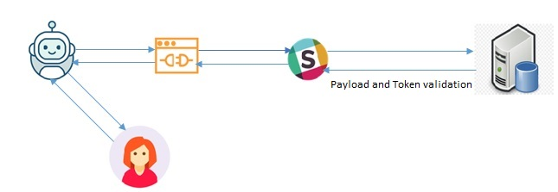

CAL FAQ WORKING :

CAL EXAMPLE SNAP:

CAL DOCUMENTATION WORKING:

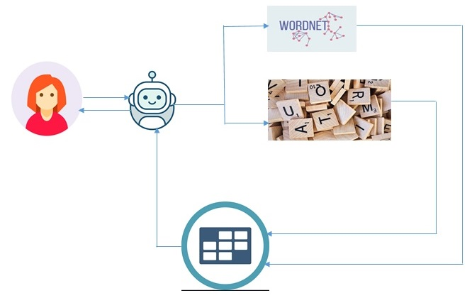

CAL DOCUMENTATION SNAP:

INTERACTIVE THINGS AS FUTURE ENHANCEMENT:



Help Command:

* Before

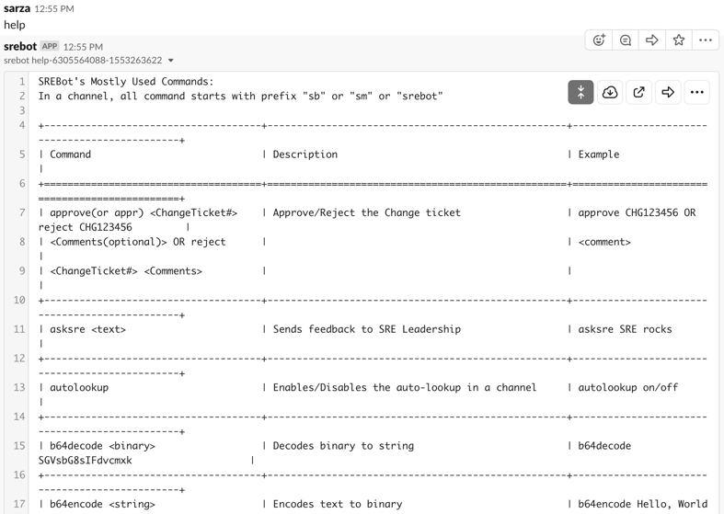

* After:

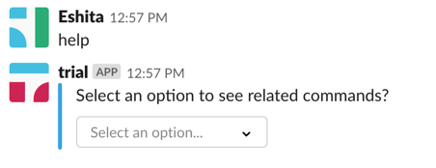 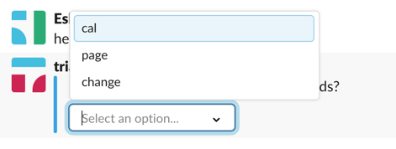

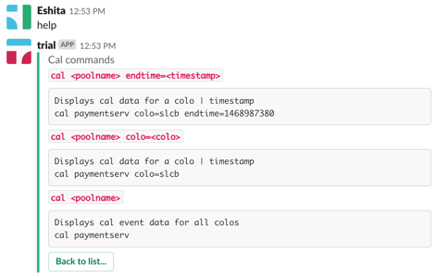

Bug Notification:

Before

 



AFTER

 